Abbot’s Hall Primary School
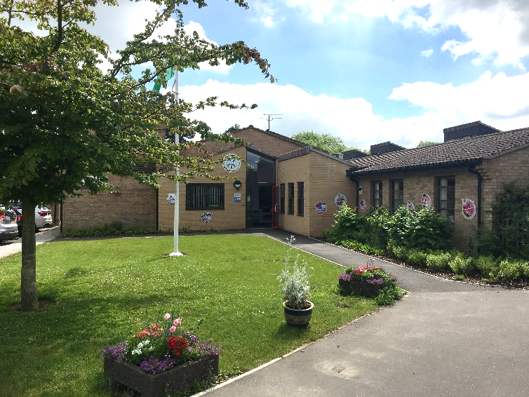
A member of Children’s Endeavour Trust
Learning Support Assistant to support SEN Pupils from across several year groups
(This is a fixed-term position from September 2026 to August 2027. This position may be reviewed if one of the pupils leaves)
Grade 3 Point 4
38 weeks per year, 30 hours 50 minutes per week,
6 hours 10 minutes per day (including half an hour lunchtime support)
8.40am to 3.20pm (half an hour lunch break)
£18,088.62 (£26,016 pro rata) £13.48 per hour

We are looking to appoint a learning support assistant on a fixed term contract to support the pastoral needs, learning, progress and attainment of a small number of pupils with complex SEN needs. As part of the role, you will work closely with the SEN HLTA, Class Teachers, SENCo and other teaching assistants to support a small group of children with Special Educational Needs who require a bespoke provision, support other pupils across the school as directed, deliver interventions to individuals or small groups as time allows and support the children for part of lunchtime. The successful candidate must be able to work across all year groups from Reception to Year 6.

What attributes you will need
- an amazing communicator
- good team player
- calm, nurturing, patient, kind and caring
- flexible and enthusiastic in your approach to the children’s and school’s needs
- positive, approachable and understanding
- able to support a diverse range of needs

We are seeking someone with school-based experience anywhere from Reception to Year 6. Experience working with children, providing interventions, supporting children with special needs, working 1:1, with small groups and whole class support is highly desirable.

Experience and/or qualifications in working with and supporting pupils with behaviour or learning needs is highly desirable.

You must have obtained a grade C/4 or above in English and maths at GCSE or equivalent or be working towards this.

About us
Abbot’s Hall is a two-form school in Stowmarket with 365 children on roll from Reception to Year 6. We are an inclusive school and are an Inclusion Quality Mark Centre of Excellence; and we have recently achieved Rights Respecting Schools Gold status. We are a well-resourced school and have lovely outdoor grounds that support outdoor learning.

What will offer you
- a welcoming, friendly and supportive staff team dedicated to raising standards
- happy children who are eager to learn and make the most of their time in our school
- a school that strives for every child to reach their true potential
- supportive leadership team and governors
- a well-resourced environment.

For more information
For further details or to arrange a visit to the school please contact Mrs Hannah Jewers at the School from the 1st of September.
Tel: (01449) 612818 Email: office@abbotshall.suffolk.sch.uk
Website: https://www.abbotshall.suffolk.sch.uk

How to apply
Application form and job description can be found on the school website or on Suffolk Jobs Direct. Completed application forms should be emailed to office@abbotshall.suffolk.sch.uk FOA Hannah Jewers.

Closing date: 12pm, Friday 4th September 2026.
Interview date: W/B: 7th September 2026.

