Wednesday 10th June 2026

Fundraising Colour Run for Our Early Years Outdoor Area

Dear Parents and Carers

We are excited to announce our upcoming Colour Run Fundraising Event, which will take place on Thursday 16th July.

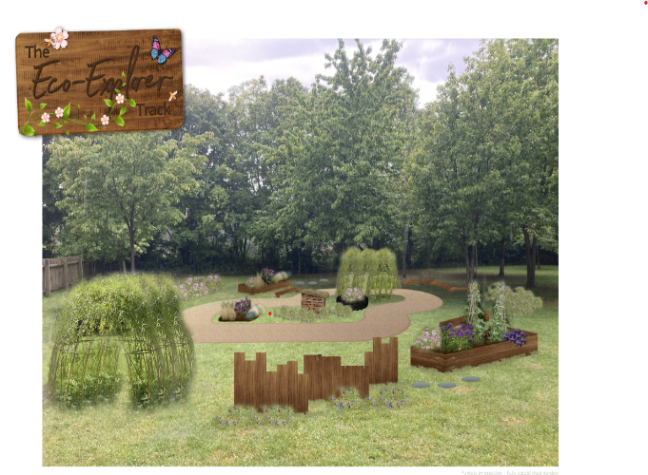
Our goal is to raise funds to improve and develop our Early Years outdoor area, creating a safe, stimulating, and engaging environment where our youngest children can learn, explore, and thrive through outdoor play.

Outdoor learning plays a vital role in children's development, helping to build confidence, creativity, physical skills, and a love of nature. With your support, we hope to enhance our outdoor space with new play equipment, sensory resources, planting areas, and learning opportunities that will benefit children for years to come.

While the project is centred on Early Years provision, the benefits will be felt across the whole school. Older children will have opportunities to access learning experiences, develop leadership skills through supporting younger children, and engage with environmental and wellbeing initiatives.

The Colour Run promises to be a fun-filled event for our children. Participants will run, walk, or jog around the course while being showered with colourful powder at designated stations. It will be an afternoon of laughter, community spirit, and memorable experiences for everyone involved.

In order to cover the cost of the event, we are asking participants to fundraise a minimum of £5. To help us move closer to our fundraising goal we would like children to collect further sponsorship from family and friends if they wish - every contribution, no matter the size is welcome. If you do not want to enter the colour run, your child will still be able to take part in a non-colour run if they would like to.

Your child will need to come into school on that day in old clothes, including a white t shirt. Your child is welcome to bring in sunglasses or goggles to wear during the event if they wish.

The collecting of sponsorship will be cashless using the online system ‘Superkind’. Please follow the instructions below on how to set up.

How to set up:
- View your child’s class campaign by clicking the link for here:

Mrs Scrivener and Mrs Brown https://superkind.org/campaign/friends-of-abbots-hall-school-reception-mrs-scrivener-mrs-brown-colour-run-2026
Miss Payea https://superkind.org/campaign/friends-of-abbots-hall-school-miss-payea-reception-colour-run-2026
Mr Dunne https://superkind.org/campaign/friends-of-abbots-hall-school-year-1-mr-dunne-colour-run-2026
Mrs Cook and Mrs Evans https://superkind.org/campaign/friends-of-abbots-hall-school-year-1-mrs-evans-mrs-cook-colour-run-2026
Miss Smith https://superkind.org/campaign/friends-of-abbots-hall-school-year-2-miss-smith-colour-run-2026
Mrs Thomas https://superkind.org/campaign/friends-of-abbots-hall-school-year-2-mrs-thomas-colour-run-2026
Mrs Rogers and Mrs Cox https://superkind.org/campaign/friends-of-abbots-hall-school-colour-run-2026
Miss Morris https://superkind.org/campaign/friends-of-abbots-hall-school-year-3-miss-morris-mrs-cox-colour-run-2026
Mrs Goodenough https://superkind.org/campaign/friends-of-abbots-hall-school-year-4-mrs-goodenough-colour-run-2026
Mrs Vaughan https://superkind.org/campaign/friends-of-abbots-hall-school-year-4-mrs-vaughan-colour-run-2026
Mrs Childs https://superkind.org/campaign/friends-of-abbots-hall-school-year-5-mrs-childs-colour-run-2026
Miss Paterson https://superkind.org/campaign/friends-of-abbots-hall-school-year-5-miss-patterson-colour-run-2026
Mr Aldred and Mrs Starling https://superkind.org/campaign/friends-of-abbots-hall-school-year-6-mr-aldred-mrs-starling-colour-run-2026
Mrs Flory and Mrs Langford https://superkind.org/campaign/friends-of-abbots-hall-school-year-6-mrs-flory-mrs-langford-colour-run-2026

- Click on ‘Join this campaign’.
- Login or create an account as a child/parent.
- As a parent/guardian you will need to approve the account and fundraiser via email (before it goes live).
- Create a fundraising page and share with friends and family via, email or messages.

We greatly appreciate your generosity and support. Together, we can create an inspiring outdoor environment that enriches the learning and development of all our children.

Thank you for helping us make a difference.

Yours sincerely,

Mrs E Scrivener, Mrs H Brown and Miss T Payea

