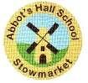

Spring Term 2026
Parents’ Curriculum Information

Lower Key Stage 2 (Year 4)

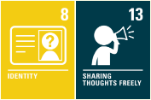
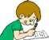
English

At the start of the term, we will be reading ‘Llama out loud’ by Annabelle Sami. We will explore the characters, make predictions about what will happen next and work on building our inference and summarising skills. We will use the context of the book to inspire writing a persuasive advert and calligram.
In the second half of the term, our class novels will be ‘Toxic’ by Mitch Johnson and ‘Rangtan in my bedroom’ by James Sellick. These will form the basis of our reading and writing lessons connecting with our learning about the rainforest including writing a letter and making a persuasive leaflet.
Spellings will be learnt in classes and, at the start of each half term, pupils will still be given a list of words that link to the focus of that week.

Maths

In Maths this term we will continue our learning on number work and calculations involving multiplication and division, length and perimeter and fractions before half term. After half term, learning will then continue with some fractions work before progressing onto decimals and some lessons to consolidate previous sessions. Children can still access the Times Tables Rock Stars website with their own usernames and passwords to allow for additional practise at home.

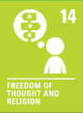

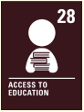
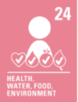
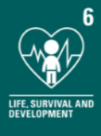

Science, History and Geography

Our topic for this term is the Rainforest. We will be looking at where in the world they are, what the climate is like and what life is like, as well as finding out how to protect the world’s Rainforests. Our geography learning will cover lines of latitude and longitude, the tropics of Cancer and Capricorn and vegetation belts and biomes. In our history learning, we will be learning about the Mayan Civilisation and how this contrasts with British history, beliefs and traditions of the cultures over time. Our science learning will cover living things and their habitats and focus on the classification of animals. We will look at how to make a branching key diagram to sort animals based on their features.

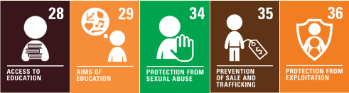
Computing and Online Safety

In computing, we will be learning how to handle data. We will be using a range of electronic devices to learn, understand and even create our own weather report. As well as this we will explore why spending too much time using technology can have a negative impact on a person.

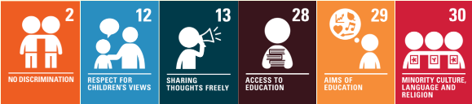

PSHE and RE

In PSHE, we will be looking at the puzzle pieces ‘Dreams and Goals’, focusing on setting realistic goals, and ‘Healthy Me’, focusing on making choices that benefit our physical and mental health. Occasionally, PSHE lessons can raise sensitive issues so should there be any topic that you think may affect your child, please let the class teacher know in advance. We will be looking at some aspects of the religion of Hinduism, focusing on the concept of Dharma, as well as looking at features of the religion of Sikhism including the ten gurus.

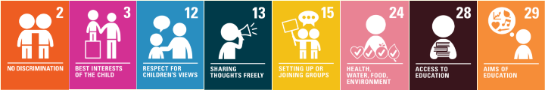
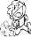
PE

Pupils will have two PE lessons each week. Outdoor PE lessons will cover tag rugby and fitness where we will be looking at the rules and learning the basic skills of passing, scoring and defending. Indoor PE will be dance where the children will be creating characters and narrative through movement and gesture. We will then focus on improving our mobility and flexibility by completing a range of yoga sessions.
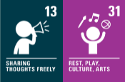


Art, Music and Design and Technology

In the Spring term, our art focus will be craft and design: looking at the fabric of nature. This involves looking at the artist William Morris and taking inspiration from his work to create our own pieces. In DT, our focus will be on adapting and making a biscuit recipe. We will also look at different types of fastenings to create our own book sleeve in our second DT topic of Spring Term. Our music lessons will focus on body and tuned percussion with a rainforest theme and we will be learning about changes in pitch, tempo and dynamics with a river theme.

Please see the monthly newsletters from Mr Pettitt or the calendar on our school website to keep up with key dates and events for our Year Group.

Have a wonderful summer term!
Mrs Vaughan, Mrs Goodenough and Mrs Cox

Be The Best You Can Be.

