Dear Parents/Carers,

I hope this letter finds you well and you have enjoyed a restful Christmas break.

Following the news that Ince’s, the only school uniform provider for Abbot’s Hall, will be closing this month, the Governing Body and I are reviewing our school uniform, specifically the primary colour used. We believe a refresh, potentially including a change in the main uniform colour, could offer benefits in terms of ensuring greater cost-effectiveness and availability for all families.

Why we are considering this change:
Affordability:
- Our investigation in to a new uniform provider has highlighted that brown is not available with many school uniform providers and where it is, it is more expensive.
- Moving to a more available colour would allow families to buy non-logo school uniform from supermarkets at a more affordable price.
- To ensure the cost of uniform with the school logo remains low and accessible to all.
- Changing to a more available colour will allow the school to explore a wider number of school uniform providers to ensure parents and carers are getting the best value.

Identity:
- The logo will remain the same.
- We have looked at the colour of the school uniform for other local primary schools in Stowmarket and royal blue or bottle green are not used.
- Items with the school logo will be kept to a minimum e.g. school sweatshirt, cardigan, book bag and optional school coats/fleeces.

Comfort & Practicality:
- To explore colours and fabrics that are more comfortable and durable for daily wear, making it easier for students to feel ready to learn.

Transition:
- Should we transition to a new colour for our school uniform, this will be done gradually with all new uniform purchases in the new colour whilst allowing children to continue to wear the brown uniform for the foreseeable future (1-2 years).
- The colour of gingham dresses will be considered once the colour of the uniform has been decided.
- A new provider would be established to supply the new uniform online from the summer term.
- In the meantime, the Friends of Abbot’s have good quality second hand uniform to purchase whilst the transition takes place.
- Children with older siblings will continue to be able to wear the old uniform for the foreseeable future (1-2 years).
- The new school uniform will be expected for each new year group moving forward e.g. Reception in September 2026.

We want to hear from you!
Your opinions are vital in shaping this decision. We are asking for your feedback on a potential new colour, royal blue, bottle green or staying with brown for the logo uniform items parents and carers want to be available. This will help us to find the best online supplier to provide the school uniform moving forward.

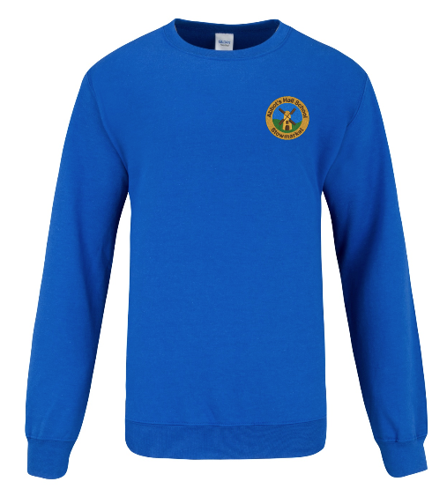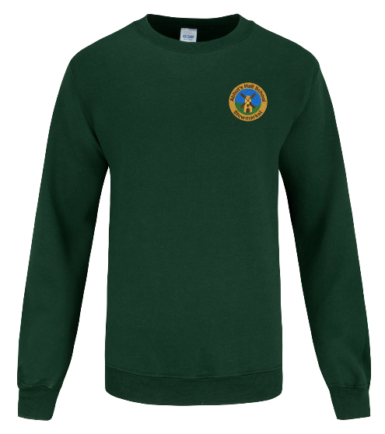

How to provide your input:
- Online Survey: Please complete our short survey by Monday 12th January at 9am:

https://docs.google.com/forms/d/e/1FAIpQLSfbBzexfAPjkI1Sozqi0S8zhFvLx_WueN_Pt3gHFNuN1iFu9w/viewform?usp=header

- Written Feedback: Send any written thoughts to the school office by Monday 12th January at 9am.

We value your partnership and look forward to your contributions as we work together to create a uniform that serves our entire school community effectively.

Yours sincerely,
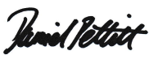
Mr Daniel Pettitt
Headteacher

