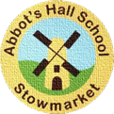
Abbot’s Hall Community Primary School
Curriculum Overview Year 3 2024-2025
 | Autumn Term  Around the World |  | Spring Term  The Stone Age |  | Summer Term  Roman Britain
Rights respecting school Articles Highlighted in red where links can be made.
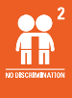
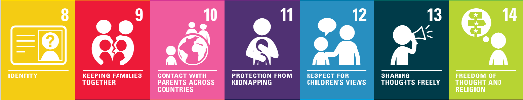
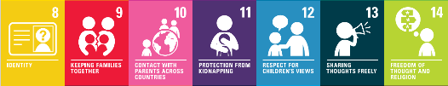
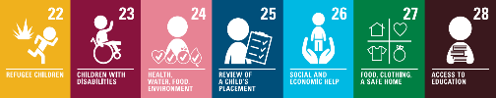
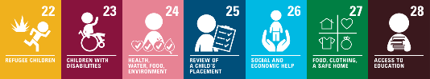
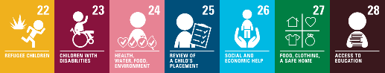
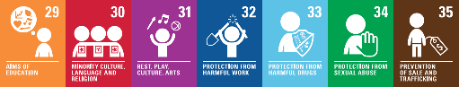
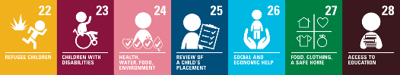

English  Twinkl Spelling Scheme  Penpals Handwriting | Narrative  Descriptive writing  Non-Chronological reports: Information leaflets  Character description  Newspaper report  Poetry | Zeraffa Giraffa  A kid’s guide to Rome  Kai and the Monkey King  Sheep Pig  Haiku Poems | Instructions  Letters  Narrative | Ug: Boy Genius of the Stone Age  Stone Age Boy  Stig of the Dump  A Bear Called Paddington | Non-Chronological reports: Fact files about Science topic 'Light'  Poetry  Play scripts | Sam Wu is not Afraid of the Dark  Escape from Pompeii  Romans on the Rampage
Maths  White Rose Maths Hub | Number: Place Value Addition and Subtraction  Multiplication and Division A |  | Multiplication and Division B, Length and Perimeter  Fractions A, Mass and Capacity |  | Fractions B  Money, Time  Shape, Statistics
Science | Forces and Magnets Working scientifically objectives taught throughout the year |  | Rocks and Soils  Plants |  | Light  Animals including Humans
History/  Geography | Geography: Locate world countries and capital cities of Europe on map – environmental regions, human/physical characteristics. |  | Geography: Key aspects of human geography, including types of settlement & land use, map and Atlas skills  History: How did life change from the Stone Age to the Iron Age? |  | History: Roman Britain
Art  Kapow | Abstract shape and space |  | Prehistoric painting  Growing artists |  | Making scrolls
Art  Kapow | All Art units should cover: Articles 31 and 13. A31 - The right to access culture and arts. Article 13 - the right to share thoughts freely and creatively through art.
DT  Kapow | Eating seasonally (cooking and nutrition)  Electronic charm (digital world) |  | Cushions (textiles)  Pneumatic toys (mechanisms / mechanical systems) |  | Constructing a castle (structures)
DT  Kapow | All DT units should cover: Articles 31 and 13. A31 - The right to access culture and arts. Article 13 - the right to share thoughts freely and creatively through art.
Music  Kapow | Traditional instruments and improvisation  Christmas performance |  | Pentatonic melodies and composition (Theme: Chinese New Year)  Developing singing technique (Theme: The Vikings) |  | Creating compositions in response to an animation  Ballads
Music  Kapow | All music units should cover rights articles: A13 and A31. Access to culture, art and music for enjoyment and expressing yourself freely through music.
Computing  Kapow | Computing systems and networks: networks 1  Programming – Scratch |  | Computing systems and networks 2: Emailing.  Creating media - Video trailers |  | Computing systems and networks 3: journey inside a computer.  Data handling: comparison cards database.
Computing  Kapow | All computing units should cover the right articles: to be protected from online abuse A34, A35, A36 and the right to education and how to use computers A28, A29.
Online Safety | Self-image and identity: Online identity  Online Bullying: What is online bullying and how could someone get support? |  | Online reputation: Sharing personal information online  Health, wellbeing and lifestyle: age restrictions |  | Online relationships: Trusting information and people online  Managing online information: difference between belief/opinion and fact
RE  Emmanuel Project | Christianity: reconciliation  Islam: seal of prophets |  | Hinduism: the story of Rama and Sita  Symbols & Religious Expression: How religious & spiritual ideas are expressed  Christianity: Why is the cross more than a symbol of sacrifice? |  | Beliefs in Action in the World: How religions respond to global issues  Christianity: Kingdom of God  Revisiting Judaism: Symbols and Religious Expression
RE  Emmanuel Project | All RE units should cover these rights: Right to education and respect for other:. A28 and A29, Right to an opinion and expressing what I think: A12 and A13  Protection from religious discrimination: A2, Freedom to practice own religion and culture: A30.
MFL  Mr French | France and its culture, Greetings, Numbers 0-20, Age |  | Colours, Numbers 20-50 |  | The date and birthday, My Family
MFL  Mr French | All French units should cover these rights: Right to education A28, Right to language A30, Right to culture A31
PSHE  Jigsaw | Being Me in My World  Right to family guidance as children develop A5, Right opinion A12, Right to share A13, Right to freedom of thought and religion A14, Right to protection of privacy A16, Right to Education A28, Right to develop talents A29  Celebrating Differences (including Anti-Bullying)  Right opinion A12, Right to share A13, Right to freedom of thought and religion A14, Right to protection of privacy A16, Right to Education A28, Right to develop talents A29, Right to minority culture, language and religion A30 |  | Dreams and Goals  Right opinion A12, Right to share A13, Right to freedom of thought and religion A14, Right to protection of privacy A16, Right to Education A28, Right to develop talents A29  Healthy Me, including healthy lifestyle workshop.  Right opinion A12, Right to share A13, Right to freedom of thought and religion A14, Right to protection of privacy A16, Right to health, water, food and environment A24, Right to Education A28, Right to develop talents A29, Right to protection from harmful drugs A33 |  | Relationships  Right opinion A12, Right to share A13, Right to freedom of thought and religion A14, Right to protection of privacy A16, Right to protection from violence A19, Right to health, water, food and environment A24, Right to food, clothing and a safe home A27, Right to Education A28, Right to develop talents A29, Right to rest, play, culture and art A31  Changing Me (including Sex Education)  Right opinion A12, Right to share A13, Right to freedom of thought and religion A14, Right to protection of privacy A16, Right to health, water, food and environment A24, Right to Education A28, Right to develop talents A29, Right to minority culture, language and religion A30, Right to protection from sexual abuse A34
PE  Get Set 4 PE | Swimming and Ball Skills OR Basketball and Ball Skills  Swimming and Dance OR Outdoor Adventurous Activities and Dance |  | Swimming and Gymnastics OR Gymnastics and Basketball  Swimming and Football OR Football and OAA  Classes will swap for swimming lessons in Spring 1 |  | Swimming and Athletics OR Athletics and Cricket  Golf and Tennis
PE  Get Set 4 PE | All PE units should cover these rights: Right to protection against discrimination A2, Right for adults to do what is best (safety rules) A3, Right opinion A12, Right to share A13, Right to make friends A15, Right to be protected from harm A19, Right of disabled people A23, Right to Best Health A24, Right to Education A28, Right to develop talents A29, Right to Play and Rest A31.
SMSC/British Values | Voting for roles within the school such as school councilors and sports ambassadors, Anti-bullying week, Black History month, Remembrance Day, Enterprise Day, Christmas performance at the local church,  Rights Respecting School assemblies throughout the year  Friendly Fridays and Year group assemblies to parents each term |  | World Book Day, Science Week, Visit from an archaeologist, Easter |  | Visit to Colchester Castle, Sports Day and Active Week

