Abbot’s Hall Community Primary School
Curriculum Overview Year FS 2025-2026
 | Autumn 1 –  All About Me | Autumn 2 –  Celebrations Around the World | Spring 1 –  Time Detectives | Spring 2 -  When I Grow Up | Summer 1 –  Near and Far | Summer 2 – Growing
Rights respecting school Articles Highlighted in red where links can be made.
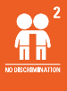
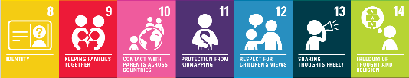
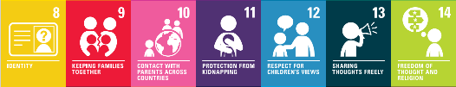
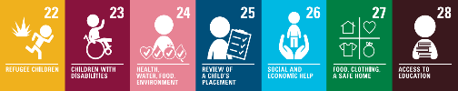
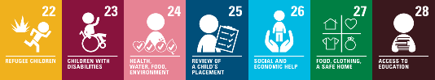
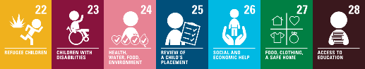
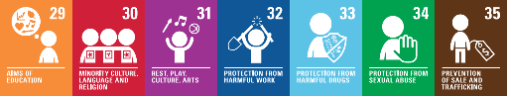
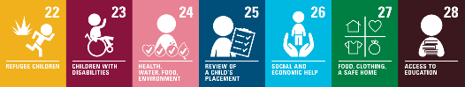

Literacy  - Reading Planet Books  - Rocket Phonics | Senses  Brown Bear, Brown Bear  My Hair  Comparisons to our Grandparents.  We are Family  Oliver’s Vegetables  Pumpkin Soup That’s not my… books Creating a class book, mark making and name writing, speaking and listening, verbally retell the story | Roaring Rockets  Lest We Forget/Where the Poppies Now Grow videos  First Festivals Diwali and Hanukkah  Thanksgiving: Thankful Tree  Christmas  Rhyme, mark making/labels/ caption writing/ lists | Mary Anning  I Saw a Dinosaur  How to Grow a Dinosaur?  Harry and the Dinosaurs books  Non-fiction, writing captions, labels, story writing | Clothesline Clues to Jobs People Do  World Book Day (linked book)  My First Heroes books  Science Week  When We Grow Up  Writing clues, linked to WBD, writing a fact file, speaking and listening, | A Place Called Home  We Are All Neighbours  Lost in the City  Habitats: Where Is My Home: A children's story book  My World Your World  Postcard writing, fact sentence writing, comparison writing | Very Hungry Caterpillar  Jasper’s Beanstalk Teeny Weeny Tadpole Oi Frog!  Oracy, story writing of familiar story, writing a new ending, lifecycle writing, rhyming
Communication and Language Key focus: Oracy through listening, retelling, role-play, discussion & adult modelling using past, present & future tense and conjunctions | All About Me - Listen, articulate ideas & thoughts including new vocabulary; Engage in story times; Retell stories with some exact repetition and some own words  Engage in non-fiction books; Listen to and talk about selected non-fiction to develop a deep familiarity with new  knowledge & vocabulary  Year Group Assembly | Describe events; Listen to & talk about stories; Continue to retell stories with some exact repetition and some own words; Using new vocabulary in different contexts; Listen to rhymes & songs; Learn rhymes, poems & songs  Nativity | Describe events; Listen to & talk about stories; Continue to retell stories with some exact repetition and some own words; Using new vocabulary in different contexts; Listen to rhymes &  songs; Learn rhymes, poems & songs  Year Group Assembly | Listening, Attention &  Understanding: Listen & respond during whole class, small group & 1:1 discussions; Make comments about what is heard & ask questions to clarify understanding Speaking: Join discussions with own ideas, using key vocabulary; Express ideas & feelings using present tense | Listening, Attention & Understanding: Listen & respond during whole class, small group & 1:1 discussions; Make comments about what is heard & ask questions to clarify understanding Speaking: Join discussions with own ideas, using key vocabulary; Express ideas & feelings using present tense. | Listening, Attention &  Understanding: Listen & respond during whole class, small group & 1:1 discussions; Engage in back & forth exchanges with teacher & peers  Speaking: Offer explanation for why things might happen, making use of recently key vocabulary from shared texts  Year Group Assembly
P.S.E.D  Jigsaw | Being Me In My World  Class expectations and routines Starting school books  12 – Respect for children’s views 13 – Sharing thoughts freely 14 – Freedom of thought and religion 16- Protection of Privacy 28- Access to Education 29- Aims of Education 24 – Health, water, food and environment 31 – Rest, play, culture, arts. | Celebrating Difference  Making relationships – Talk Partners and shared games Mr Gumpy’s Outing  12 – Respect for children’s views 13 – Sharing thoughts freely 14 – Freedom of thought and religion 16- Protection of Privacy 28- Access to Education 29- Aims of Education 30 – Minority Culture Language and Religion | Dreams and Goals Six Dinner Sid  12 – Respect for children’s views 13 – Sharing thoughts freely 14 – Freedom of thought and religion 16- Protection of Privacy 28- Access to Education 29- Aims of Education | Healthy Me  The world of work  People who help us  12 – Respect for children’s views 13 – Sharing thoughts freely 14 – Freedom of thought and religion 16- Protection of Privacy 24 – Health, Water, Food and Environment 28- Access to Education 29- Aims of Education 31 – Rest, Play, culture, arts | Relationships  Road safety  Walk to town and post box  Show sensitivity to other’s needs  12 – Respect for children’s views 13 – Sharing thoughts freely 14 – Freedom of thought and religion 16- Protection of Privacy 28- Access to Education 29- Aims of Education 30- Minority Culture Language and Religion | Changing Me  Transitions  Healthy Eating/Active week  12 – Respect for children’s views 13 – Sharing thoughts freely 14 – Freedom of thought and religion 16- Protection of Privacy 24 – Health, water, food and environment 28- Access to Education 29- Aims of Education
Online Safety Kapow Collective Worship | Computing systems and networks 1: Using a computer | Programming 1: All about instructions | Computing systems and networks 2: Exploring hardware | Programming 2: Programming Bee-Bots | Data Handling: Introduction to data
All online safety units should cover the right to be protected from online abuse A34, A35, A36 and the right to education and how to use computers A28, A29.

Maths  White Rose Maths | Getting to Know You,  Match, Sort & Compare  Talk about measure & patterns  It’s Me 1,2,3! representing 1,2,3,Count objects, actions & sounds, Subitise, Link number symbol (numeral) with its cardinal number value | It’s Me 1,2,3! continued  Circles & Triangles  1,2,3,4,5  Shapes with 4 sides  Positional vocabulary  Representing numbers to 5, One more  & less, Shapes with 4 sides, Day & night | Alive in 5! – Comparing numbers to 5,  Composition of 4 & 5, Comparing Mass  & Capacity  Growing 6,7,8 – Making pairs, Combining two groups | Growing 6,7,8 - Length & Height, Time  Building 9 & 10 - Comparing to 10,  Bonds to 10, 3-D Shapes, Patterns | To 20 and Beyond - Subitising, Counting, Composition, Sorting & Matching, Building & counting pairs beyond 10, Spatial  reasoning; First Then Now - Adding more,  Taking away, Spatial reasoning | Find My Pattern – Doubling, Sharing & grouping, Even & odd, Spatial reasoning; On The Move -  Subitising, counting, composition, sorting & matching, comparing & ordering, Patterns & relationships,  Spatial reasoning, Visualise, map and build, make connections
Understanding the World | People, Culture and Communities: Begin to make sense of own life story and family history, Languages Day  The Natural World: Use senses to explore materials.  Seasons – Autumn | People, Culture and Communities: religious and cultural celebrations, understand special places for members of their community, recognise different beliefs and how special times are celebrated in different ways.  The Natural World: Describe what they see, hear and feel whilst outside.  R.E – Christianity and Islam | Past and Present: Understand the past, similarities and differences from the past and now, drawing on their experiences, dinosaurs.  The Natural World: Seasons – Winter, changing states of matter, similarities and differences between the natural world around them and contrasting environments. | Past and Present: Talk about members of their family and community, talk about the lives of the people around them and their roles in society.  Science Week  The Natural World: Seasons – Spring Forest Sessions  R.E – Christianity | People, Culture and Communities:  Similarities and differences between life in this country and other countries, including use of maps.  Similarities and differences between different religious and cultural communities in this country.  Local walk – create own maps  The Natural World: Recognise environments different to where they live including contrasting environments including fieldwork forest School Trip | The Natural World:  Explore the natural world around them, making observations and drawing pictures of animals and plants understand important processes and changes - growing plants, lifecycles  The Natural World: Seasons - Summer  R.E – Hinduism, Judaism and Christianity
All RE units should cover these rights: Right to education and respect for other:. A28 and A29, Right to an opinion and expressing what I think: A12 and A13
Protection from religious discrimination: A2, Freedom to practice own religion and culture: A30. UW (Science) -

Expressive Arts and Design  Kapow | Art and Design - Drawing: Marvellous Marks  Sing well-known nursery rhymes & songs  Andy Goldsworthy-Natural art | Design and Technology – Structures: Junk Modelling  Celebration Music  Sing and perform songs, poems & rhymes (Nativity Production) | Art and Design – Painting and mixed media: Paint My World  Exploring Sound  Creating Box-o-saurus | Design and Technology – Structures: Boats  Music and Movement  Forest den building, clay faces, Stickman | Art and Design - Sculpture and 3D design: Creation Station Sculpture  Design and Technology – Textiles: Bookmarks  Musical Stories | Art and Design – Craft and Design: Let’s Get Crafty!  Big Band  Very Hungry Caterpillar story boxes Design and make instruments
All Art units should cover Articles 31 and 13. A31 - The right to access culture and arts. Article 13 - the right to share thoughts freely and creatively through art.
All DT units should cover Articles 31 and 13. A31 - The right to access culture and arts. Article 13 - the right to share thoughts freely and creatively through art.
All music units should cover rights articles A13 and A31. Access to culture, art and music for enjoyment and expressing yourself freely through music.
Physical  Development  Get Set 4 P.E | Indoor – Introduction to PE: Unit 1  Outdoor – Fundamentals: Unit 1 | Indoor – Introduction to PE: Unit 2  Outdoor – Fundamentals: Unit 2 | Indoor – Dance: Unit 1  Outdoor – Ball Skills: Unit 1 | Indoor – Gymnastics: Unit 1  Outdoor – Forest Skills | Indoor – Dance: Unit 2  Outdoor – Games: Unit 1 | Indoor – Gymnastics: Unit 2 Outdoor – Ball Games: Unit 2
All PE units should cover these rights: Right to protection against discrimination A2, Right for adults to do what is best (safety rules) A3, Right opinion A12, Right to share A13, Right to make friends A15, Right to be protected from harm A19, Right of disabled people A23, Right to Best Health A24, Right to Education A28, Right to develop talents A29, Right to Play and Rest A31.

SMSC/ British  Values | Welcome Wednesday  Collective worship  School Council elections  Harvest Festival  Languages Day | Collective worship  Bonfire Night  Remembrance Day  Diwali  Christmas  Nativity  Black History Month | Collective worship Chinese  New Year  Shrove Tuesday | Welcome Wednesday  Collective worship  Mothering Sunday  Forest Skills sessions  World Book Day  Science Week  Easter | Welcome Wednesday  Collective worship  Local walk - posting letter to the Mayor | Welcome Wednesday  Collective worship  Trip to Hollow Trees Farm  Father’s Day  Sports Day/ Active Week  Transition preparation

