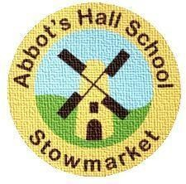
Autumn Term 2024
Parents’ Curriculum Information
Phase 1 (Foundation Stage)

Communication and Language
Literacy

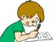
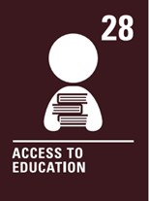
Our learning this term centers around two topics: ‘All about Me’ and after half– term we will learn about ‘Celebrations Around The World’. Throughout the term, children will experiment with mark making and developing pencil control. Children will begin to use their emergent writing for name writing, lists and labels. They will share a variety of fiction and non-fiction books to learn more about our projects. Children will read individually with an adult. Children are encouraged to continue to practise these skills though daily reading at home. Daily phonics sessions using our Rocket Phonics scheme will develop children's understanding and use of letter sounds. We will have daily handwriting carousel sessions. Please see our weekly Tapestry to practise letter formation at home.

Mathematics



Children will learn to compare amounts, explore patterns and represent the numbers 1 – 8. They will learn to accurately count groups of objects and write numerals. They will practise subitising and using the language of 1 more or 1 less. They will sort objects by size, shape and other self-created criteria. We base our learning on the White Rose Maths framework which promotes practical learning using a range of resources.

Understanding The World
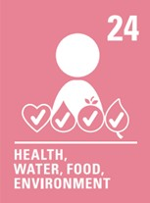
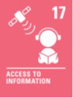
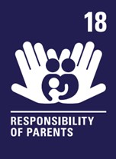
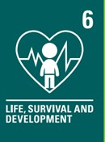
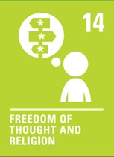
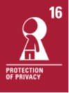


During the Autumn term we will begin to make sense of own life story and family history. We will be looking at different religious and cultural celebrations and understand special places for members of our community. We will also celebrate languages day by enjoying some French food and learning some French words. We will be investigating our own surroundings and observing the changes that Autumn time brings. We will take some nature walks into our Forest School Classroom. Online Safety will focus on ‘Self-Image and Identity’ by recognising when to say “no” online or offline to anything upsetting and ‘Copyright and Ownership’ will explore naming work to know what they create belongs to them. Religious Studies will focus on the special word God and why Christians perform nativity plays at Christmas. Children will compare simple religious beliefs and customs. They will learn more about festivals and celebrations from around the world, such as Harvest, Diwali, Thanksgiving and Christmas.

Personal, Social and Emotional Development
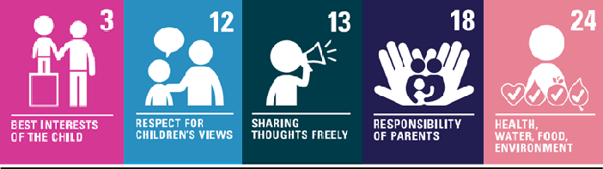



PSHE this term focuses on ‘Being me in my world’ and ‘Celebrating Differences’ and links to our whole school Jigsaw program in PSHE. This theme offers children the opportunity to see themselves as valued individuals within our school community. Children will learn about how it feels to belong and that we have similarities and differences. Throughout the theme, children will be learning about being kind and playing together. We will think about belonging to our class and what our class expectations are.

Physical Development
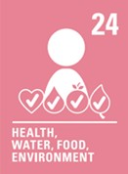


Pupils will have two PE lessons each week. Our units will be an introduction to P.E and Fundamentals. These focus on key skills such as spatial awareness and travelling in different ways. All children need to come to school in a full P.E kit on P.E days. This is a white T-shirt and black shorts, trainers and a warm, dark coloured tracksuit. Please ensure everything is clearly named. Earrings MUST be removed and long hair must be tied back before your child comes to school. This will be on a Wednesday and Thursday for both classes.

Expressive Arts and Design


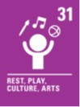

In Art and Design we will explore ‘Marvellous Marks’ which focuses on drawing skills. In Design and Technology we will learn about structures and junk modelling. Children will begin to develop the skills of performing simple songs in preparation for our Year Group Assembly and Christmas Nativity. Children will experiment with rhythmic and musical patterns using tuned and un-tuned instruments.

Please see the monthly newsletters from Mr Pettitt or the calendar on our school website to keep up with key dates and events for our Year Group.

Have a wonderful autumn term!

Be The Best You Can Be

