Maths | Science | English
Arithmetic  TIMES TABLES PRACTISE – e.g. Times Tables Rockstars  - Make some Top Trump volcano cards with different measurements.  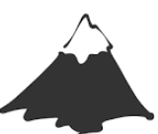  - Iceberg Areas of triangles  - Complete mini arithmetic test (there are a couple of these for you to choose from. You only need to complete one to hand in)  - Complete the Alphabet Algebra sheet | - Research medical problems climbers may encounter (eg hypothermia, altitude sickness) and how to avoid or cure them.  - Carry out experiments on things you have at home (e.g. rucksack, shoes), to see how reliable they would be for mountain climbing. Think scientifically and record your results.  - Investigate how your heart rate increases and what is happening to make it increase. Use the sheet to help you. | Reading  READING WITH AN ADULT 3-4 TIMES PER WEEK  - Read and find out about the first successful ascent of Mount Everest and summarise your findings in a short paragraph.  - Complete the Earthquakes reading comprehension.  - Read the Volcano fact files. Retrieve 10 key facts.  - Match the volcano vocabulary with the definitions. Try completing it without a dictionary at first.
Reasoning  - Find out the heights of the highest mountain in each continent in km and miles. Create a graph to compare them.  - Equivalent fractions, decimals and percentages codebreaker challenge  - Volume of cubes and cuboids activity or find cuboids around your home (tissue box etc). Measure the length, width and height to then solve the volume. Repeat 5 times.  - Complete a ten for ten arithmetic and reasoning.  - Complete reasoning paper | Year 6 – Summer 2026  Moving Earth  BOLD home learning should be completed EVERY WEEK.  Pick one other task from the grid each week.  Tasks in the ‘Topic’ section should only be completed once per half term. | SPaG  PRACTISING SPELLINGS ON THE OVERVIEW  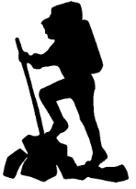  - Write a diary entry as if you were a mountain explorer using an informal tone.  - Write the start of a story that is based in a mountain range ensuring a range of description.  - Create a poem about ‘The Moving Earth’.  - Write a newspaper report about an earthquake or volcanic eruption focusing on your use of ISPACED openers.
Topic
- Mountain climbers need to be extremely fit. Think of 3 activities they could do to increase their fitness and explain/show how to complete them effectively.
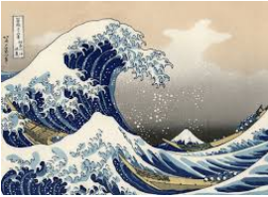
- Create your version of The Great Wave by Hokusai (image on right). You can choose what medium (paint, draw, collage) to create your masterpiece.
- Make/design an energy bar that would be suitable for a mountain climber.
- Using a world map, locate the world’s plates and the direction they are moving in.
- Create a timeline of Earth, explaining major events.
- Research Pangea and explain what it is.
- Find out about the Richter Scale and how it measures the magnitude of earthquakes.

