Year One: Ways to Support Your Child at Home
Maths
Maths is all around us. Try these simple activities to help your child with their maths skills.
- Counting up and down – Ask your child to count up e.g. from zero to twenty. Then count down from twenty to zero. Try asking them to count from a different number e.g. count up from 8 or count down from 14.
- Number Spotting – While out, ask your children to read house numbers, telephone numbers on shop signs, bus numbers etc.
- Doubling and Halving Numbers – Give your child numbers to double. How many can they get correct in one minute?
- Number Bonds – Ask your child to say two numbers that add up to 10, 20 or 100. Can they remember all the pairs of numbers of by heart?
- Board and Card Games - Snakes and Ladders, Ludo, Bingo etc
- Role play and real life experiences – shopping, menus, cooking (dividing food into fractions, doubling a recipe.
- Measuring – lengths, weights, capacity using tape measures, scales and jugs.

Writing
Children learn about writing from watching others and from the writing they see around them – things like adverts, notes, papers and letters. One of the most important ways to encourage your child to write is by providing them with a model of a writer – you!
- Ask your child to read their writing to you as they write and when they have finished. This will help them understand the importance of the reader
- Writing for a purpose - letters to friends, stories, shopping lists, making and writing greeting cards, plans for a party, postcards and diaries. Encourage writing through the use of nice notebooks or mini whiteboards.

Reading and Phonics
Children learn about reading by listening to stories, by making up a story as they turn the pages of a book and by reading print of all kinds. Reading with your child is one of the best ways to help your child learn to read. If reading is fun, your child will want to read with you.
- Children should read for 10 to 15 minutes each day.
- Before starting to read the story, talk about the cover, the title and the author and what the book may be about.
- As you read, pause to talk about the pictures, discuss what has happened and what may happen next.
If you have internet access at home, there are many good interactive games and activities online to help practice phonics (see reverse of this sheet).

Useful Phonics Websites for Parents
http://www.oxfordowl.co.uk/question/index/3  lots of information and guidance for parents/carers | http://www.bbc.co.uk/schools/ks1bitesize/literacy/phonics/index.shtml  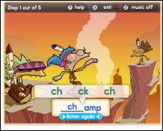  Phonic game with choice of difficulty (some HFWs, some vowel blends, very varied)
http://www.phonicsplay.co.uk/ParentsMenu.htm  a selection of interactive games for all phonic phases. Mostly simple games. | http://www.phonicsinternational.com/hear_the_sounds/hear_the_sounds_1.htm  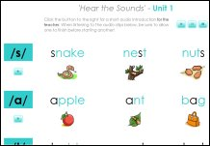 Useful page which demonstrates pronunciation of all sounds
http://www.letters-and-sounds.com/  printable resources for each of the Letters and Sounds phonic phases, also links to games aligned with each phase. | www.ictgames.com/literacy.html  a great selection of games that link well with games in Letters and Sounds.
http://www.ngfl-cymru.org.uk/vtc/ngfl/ngfl-flash/alphabet-eng/alphabet.htm  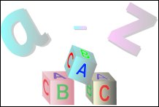  Letter names come up in alphabetical order | http://www.bbc.co.uk/schools/wordsandpictures/index.shtml  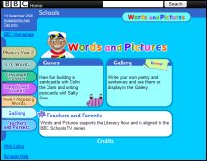  Activities for all phases

