Get active!

Walking on a line

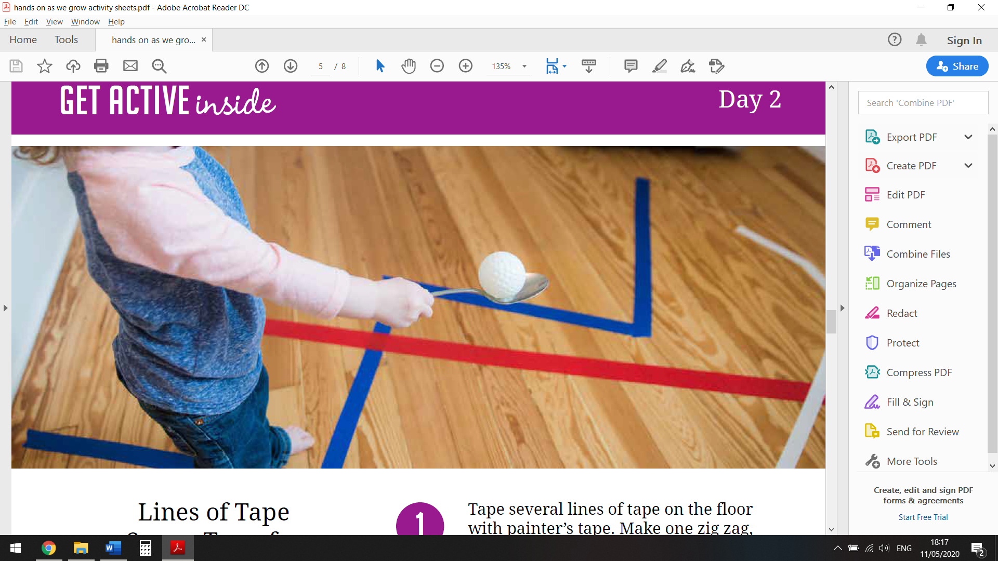

Can you find or make a line on the floor?

How could you get yourself from one end of the line to the other?

Try some of these ideas:

* Walk heel to toe
* Carry something on your head so you have to look up straight in front of you
* Use an ‘egg and spoon’, like in the picture
* Pull yourself along the line on your tummy just like a snake
* Walk backwards – be careful!
* Tiptoe along the line
* Walk like a bear on all fours or a crab sideways
* Pick up items like Lego bricks as you walk along, remember to stand up tall before you pick the next piece up

Now, how fast can you travel backwards and forwards on your line?

How many times can you go backwards and forwards in a minute?

Can you challenge someone in your house to try these activities too?