**Abbot’s Hall Primary School**

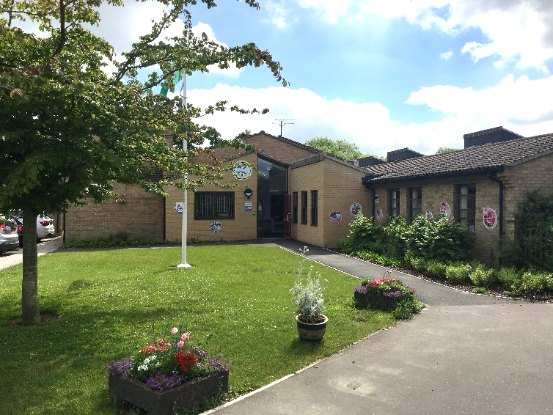

We are looking to recruit a friendly, caring

Midday Supervisory Assistant from September 2025

Abbot’s Hall is a successful and popular school in the heart of Stowmarket that benefits from a hardworking and dedicated staff, well behaved children who all want to be the best they can be and fantastic grounds.

As well as someone who enjoys working with children, the successful candidate will need to be reliable, a good time keeper, confident when dealing with pupils, a good communicator, a team player, calm and willing to undertake any training relevant to the post, including first aid.

The post involves supporting, engaging and playing with children through lunchtime and supervision of the dining hall and playground. 1 hour 35 minutes each day from 11.45am until 1.20pm.

Salary will be: Single status grade 2, point 2, £12.26 per hour (£23,657 full time equivalent).

This post is term time only (38 weeks per year), for 7 hours and 55mins (7.92) per week and is a permanent position.

This school is committed to safeguarding and promoting the welfare of children and young people and expects all staff and volunteers to share this commitment. Successful candidates are expected to respect the confidentiality of pupils and maintain professionalism at all times and will be subject to our safer recruitment process. If you accept a post at our school, you will be required to complete an enhanced DBS.

Please contact the school office for further details if you are interested or visit the school website.

Telephone: 01449 612818

Email: office@abbotshall.suffolk.sch.uk

Closing Date: 2nd July 2025

Interviews: W/C 7th July 2025