**Abbot’s Hall Primary School**

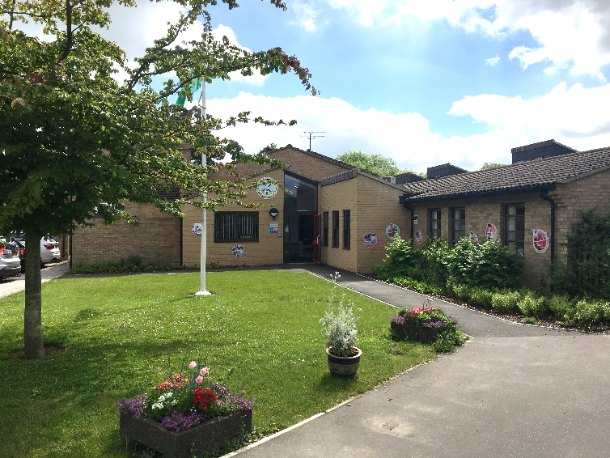

A member of Children’s Endeavour Trust.

Class Teacher

Fixed Term for maternity cover (2025/26 academic year in the first instance)

KS2

MPS1-6

Key Stage 2 Class Teacher required for September 2025 to join our friendly and successful primary school. This position is suitable for an ECT.

Abbot’s Hall is a successful and popular school in the heart of Stowmarket that benefits from a hardworking and dedicated staff, well behaved children who all want to be the best they can be and fantastic grounds.

We are seeking a skilled, dedicated practitioner who will:

* Have a secure knowledge of the primary curriculum.
* Have high expectations of pupil behaviour, progress and attainment.
* Work flexibly within a supportive, hardworking team.
* Be an exemplary and creative classroom practitioner who can effectively model good and outstanding teaching.
* Demonstrate high standards of personal integrity, loyalty, discretion and professionalism.

We will offer the successful candidate:

* Supportive team.
* Well behaved children.
* Fantastic grounds and facilities.
* Opportunities for growth and development.

Roll 365; 4-11

You are most welcome to visit the school.

For further details or to arrange a visit to the school please contact Mrs Hannah Jewers at the school.

Tel: (01449) 612818 Email: [office@abbotshall.suffolk.sch.uk](mailto:office@abbotshall.suffolk.sch.uk)

Website: https://www.abbotshall.suffolk.sch.uk/

Closing date: 15th May 2025 @ 12pm (We reserve the right to hold interviews as and when applications are received, and we reserve the right to offer a candidate the position before the closing date. All candidates are advised to refer to the job description and person specification before making an application)

Interview date: W/B: 19th May.

Abbot’s Hall and The Children’s Endeavour Trust are committed to safeguarding and promoting the welfare of children and young people and expects all staff and volunteers to share this commitment. The successful applicant with be required to have an enhanced DBS and online check carried out.

