Maths - Arithmetic | Science | English
TIMES TABLES PRACTISE – e.g. TTRS  - Research the cost of a holiday to Egypt. Add up the cost of flights, hotels and excursions.  - Complete an Ancient Egyptian themed maths sheet (from the year group page)  - Complete an Ancient Egyptian Number System sheet | - Draw a life cycle of an animal of your choice  - Research vulnerable animals that are close to extinction and present your findings  - Make a model of an animal’s habitat  - Try growing a plant in an unusual plant (e.g. cupboard, under the bed) and record what happens  - Find out about an unusual habitat | READING WITH AN ADULT 3-4 TIMES PER WEEK  - Read another book by Emma Carroll  - Write a set of instructions for mummification  - Read a book with a link to Ancient Egypt  and write a book review on it.  - Make a fact file about the Egyptian Gods  - Complete two of the Twinkl Reading tests  (on year group page)
Maths - Reasoning | Ancient Egypt – Year 5  Home Learning – Summer Term  Home learning in bold to be completed WEEKLY  Pick ONE other task from the grid each week. Tasks in the “Topic” section should only be completed once per half term. | SPaG
- Complete a maths reasoning test (on class page on webpage) – as these are quite long, complete ½ the paper.  - Create your own maths problems based on Ancient Egypt  - Make a net for a pyramid  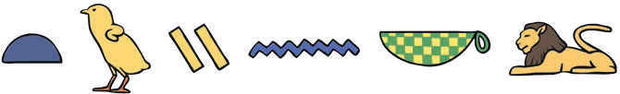 |  | PRACTISE YOUR WEEKLY SPELLINGS WITH AN ADULT  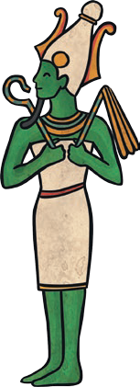  - Write ten sentences using parenthesis (brackets, dashes or commas) correctly  - Write ten descriptive sentences that start with a verb or an adjective  - Write ten sentences that use relative clauses.
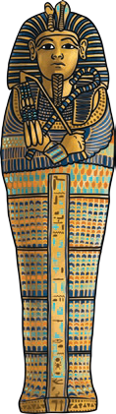
Topic
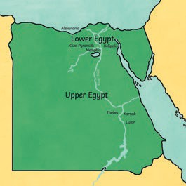
- Design and make a tomb or coffin for an Egyptian mummy.
- List 10 things you wouldn’t find in ancient Egypt and explain what they would have had instead.
- Write your name and the names of 3 friends or family members in hieroglyphics.
- Create an Egyptian themed board or card game and teach friends or family members how to play.
- Don’t forget to write a set of instructions.
- Find and research interesting landmarks in Egypt. Label them on a map with a short description.
- Find and make some Egyptian recipes.
- Create a painting or drawing of an ancient Egyptian scene using your choice of materials.

